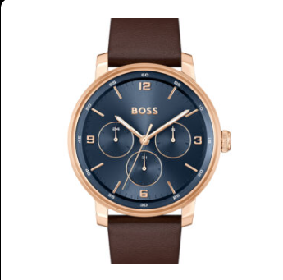

**Product Name:**

Classic Brown Leather Strap Wristwatch

**Description:**

This elegant timepiece features a **brown leather strap** paired with a **black dial**, offering a timeless and sophisticated look. The silver-colored case complements its overall design, making it suitable for both casual and formal wear. The watch includes **three hands** (hour, minute, and second) along with a **small date window** positioned at **3 o’clock**, enhancing both functionality and style.

**Specifications:**

* **Strap Material:** Brown leather
* **Dial Color:** Black
* **Case Material:** Silver-toned metal
* **Display Type:** Analog
* **Features:** Hour, minute, and second hands, date display at 3 o’clock
* **Movement:** Not specified
* **Water Resistance:** Not specified

**Price:** 24,500